**Textile Shop management system**

**Abstract:**

The Textile management system application is developed for managing the textile shop. This project is made in Macromedia Dreamweaver Mx, designing is made by JSP (Java Server Page) and the back end used is SQL server. The idea of textile shop development is how to manage the textile shop in a good manner or we can say managing the textile shop well from which people can get profit or just stay out from the difficulties, how the things is proper in the shopping mall, what is the input in the shopping mall and what is the output how to track the goods are available there or which is sort.

All this is auto track by the application from which there will be no any difficulties facing by the management after all there are certain report generation based on the shopping mall daily turnover, monthly turnover etc .

**SYSTEM CONFIGURATION:**

**HARDWARE CONFIGURATION:**

**PROCESSOR - PENTIUM-III**

Speed - 1.1 GHz

Ram - 256 MB (min)

Hard Disk - 20 GB

**SOFTWARE CONFIGURATION:**

Operating System : Windows95/98/2000/XP

Application Server : Tomcat5.0/6.X

Front End : Java

Database : Mysql

Database Connectivity : JDBC.

**EXISTING SYSTEM**

The existing system the users very hard to main the textile shop. We can’t know about the textile dress or material details manually. Sometimes it makes confusing to find the dress rates it may cause big issue.

**Disadvantages**

* Very hard to find the cost of dress.
* All works are manually implemented.
* Man power works too hard

**PROPOSED SYSTEM**

The purpose of the project is to develop a ‘Textile management system’, which will be used by the company through which all purchase details of textile can be managed by the company. The system deals with very popular interface tool retrieval of the record is which faster than the present system. Hence it cause to saving time for the further work.

**Advantages**

* Searching features is quite faster than.
* Attractive user interface.
* Billing details very easy to handle

**Modules:**

The Project contains Five Main Modules are

1. User Details
2. Customer Module
3. Manager Module
4. Item Details
5. Purchase Items
6. Report

**1. User Details:**

This modules contains add the new dealer details. It Includes are User id, name, date of birth, address, mobile number, e-mail id, password and so on.

**2. Customer Module:**

A Customer module is used to store the customers details in this module. We can search the customer details immediately. We can managing the history of customers details which is helpful to find our regular customer.

**3. Manager Module:**

This module manager can enter username and password and login their module. Manager can only added their regular customer. After login only we can access this software otherwise we can’t access.

**4. Item Details:**

This modules contains Add the new item it includes item name, id, date, unit price, manufacturing date details maintained. And view the item details, edit the item details, delete the unwanted item details maintained.

**5. Purchase:**

This modules contains are user purchase the item details maintained. It includes are item name, purchasing date, no of quantity, rate details and so on.

**6. Report:**

This Module Contains two sub Modules. They are a. User Report- user can view their past purchase history and b. Admin Report- Admin can view the user history and purchase history.

**DATA FLOW DIAGRAM**

**LEVEL 0:**

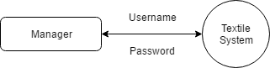

**LEVEL 1:**

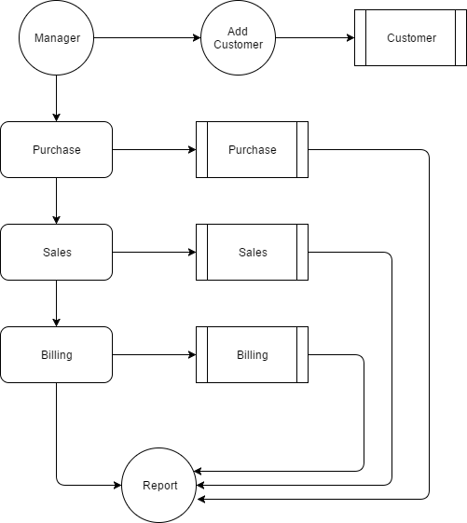

**TABLE DESIGN**

**TABLE NAME : CUSTOMER**

**PRIMARY_KEY : CID**

|  |  |  |  |
| --- | --- | --- | --- |
| **FIELD** | **DATA TYPE** | **SIZE** | **DESCRIPTION** |
| cid | Int |  | Customer id |
| Cname | Varchar | 30 | Customer name |
| Contact | Varchar | 10 | Contact no |
| Caddress | Text |  | Contact address |

**TABLE NAME : PURCHASE**

**PRIMARY_KEY : PID**

|  |  |  |  |
| --- | --- | --- | --- |
| **FIELD** | **DATA TYPE** | **SIZE** | **DESCRIPTION** |
| pid | Int | 10 | Purchase id |
| Pname | Varchar | 30 | Purchase name |
| Quantity | Int | 10 | Purchase Quantity |
| Price | Int | 10 | Purchase amount |
| Date | Date | 20 | Purchase date |
| Time | Time | 20 | Purchase time |

**TABLE NAME : SALES**

**PRIMARY_KEY : SID**

|  |  |  |  |
| --- | --- | --- | --- |
| **FIELD** | **DATA TYPE** | **SIZE** | **DESCRIPTION** |
| sid | Int | 10 | Sales id |
| Sname | Varchar | 30 | Sales name |
| Quantity | Int | 10 | Sales Quantity |
| Price | Int | 10 | Sales amount |
| Date | Date | 20 | Sales date |
| Time | Time | 20 | Sales time |

**TABLE NAME : BILLING**

**PRIMARY_KEY : BID**

**FOREIGN KEY : PID,CID**

|  |  |  |  |
| --- | --- | --- | --- |
| **FIELD** | **DATA TYPE** | **SIZE** | **DESCRIPTION** |
| Bid | Int | 10 | Billing id |
| Pid | Int | 10 | Purchase id |
| cid | Int | 10 | Customer id |
| Quantity | Int | 10 | Billing Quantity |
| Price | Int | 10 | Price of product |
| Time | Time | 20 | Sales time |
| Date | Date | 20 | Sales date |